**SSN College of Engineering Domain - Data Analytics**

**Assignment 1- Profit from the 50 start up’s dataset**

**Name:** Shruthi N

**Roll Number:** SSNCE195002113

**Branch:** Information Technology **Exploring relationships:**

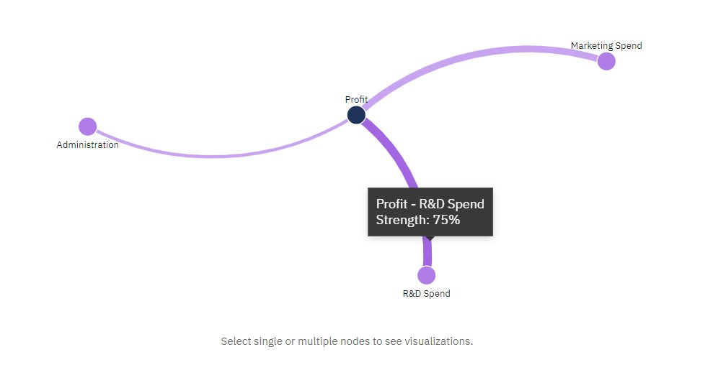

**Average Profit by State coloured by State (Bar graph):**

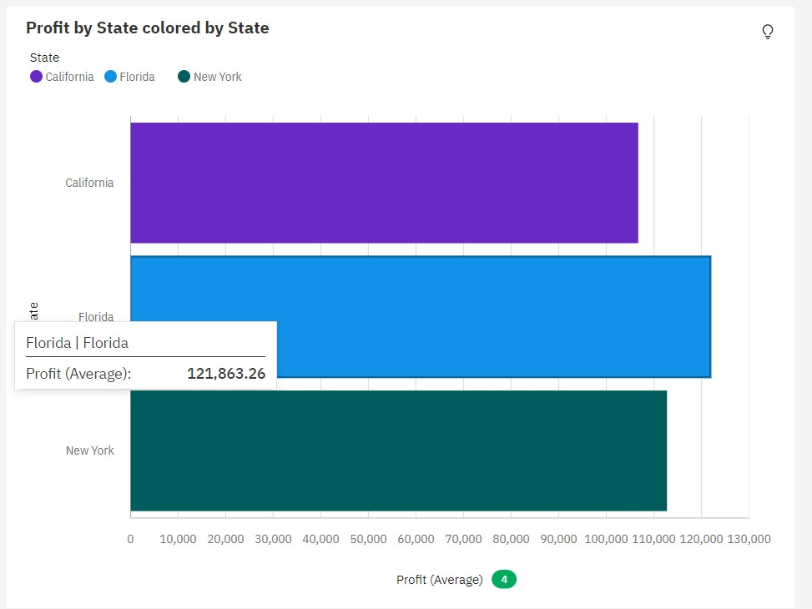

**Details:**

* The most common values of State are New York (36.1 %) and California (33.3 %), together occurring 75 times, which is 69.4 % of the total.
* Over all states and states, the average of Profit is nearly 114 thousand.
* The average values of Profit range from nearly 107 thousand to almost 122 thousand.

**Average R&D Spend by State (Pie chart):**

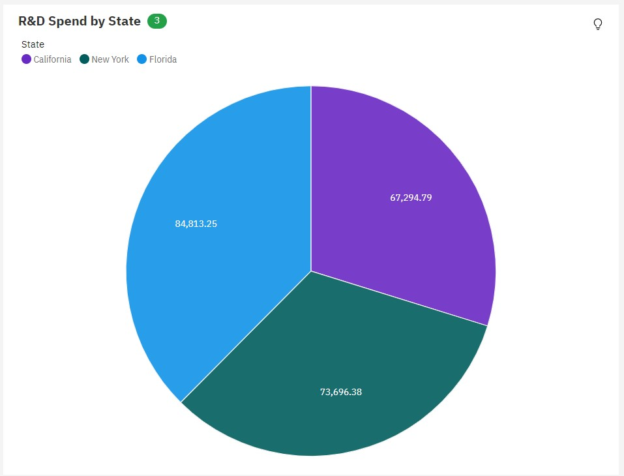

**Details:**

* Over all states, the average of R&D Spend is nearly 75 thousand.
* The average values of R&D Spend range from over 67 thousand, occurring in California, to almost 85 thousand, in Florida.
* The most common values of State are New York (36.1 %) and California (33.3 %), together occurring 75 times, which is 69.4 % of the total.

**Administration and Profit by State(Line and column chart):**

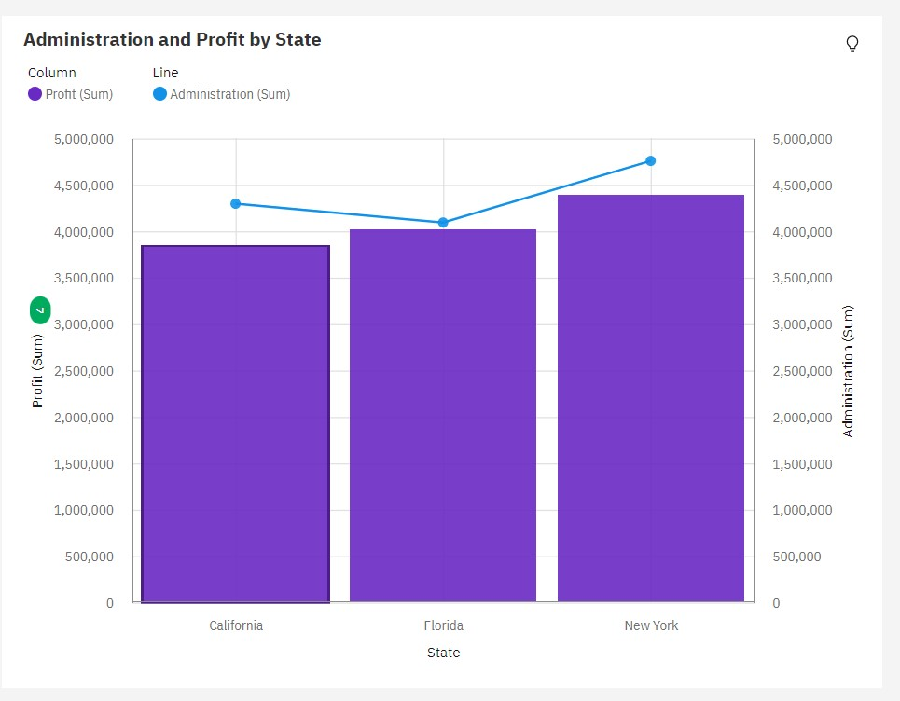

**Details:**

* Across all states, the sum of Profit is over 12 million.
* Profit ranges from over 3.8 million, in California, to almost 4.4 million, in New York.
* Across all states, the sum of Administration is over 13 million.
* Administration ranges from almost 4.1 million, in Florida, to nearly 4.8 million, in New York.

**State hierarchy coloured by State and sized by Profit (Hierarchy bubble):**

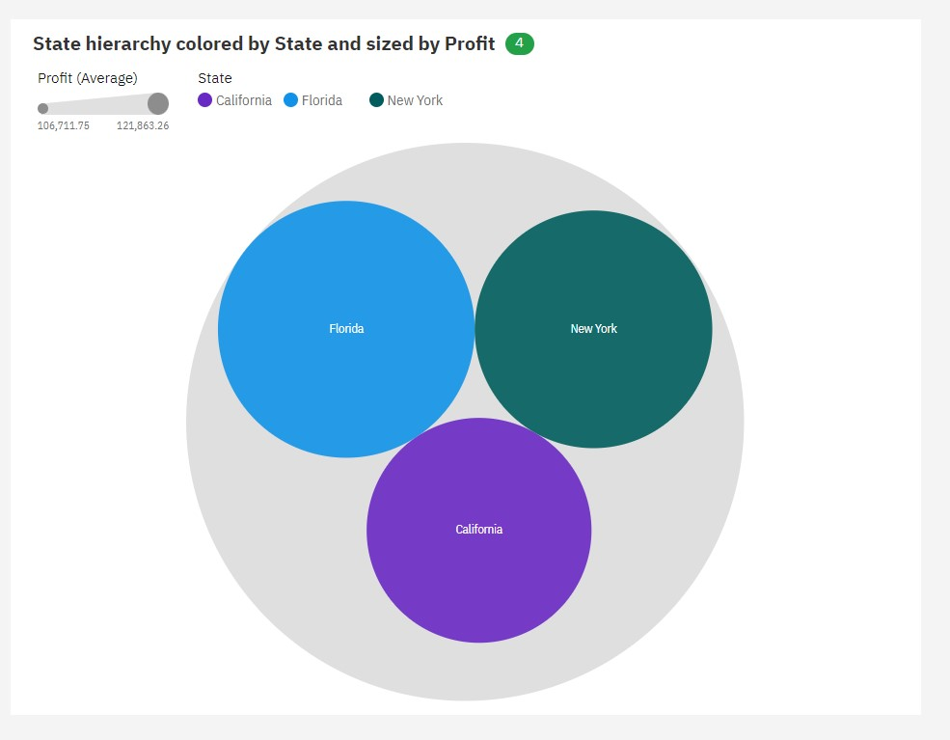

**Details:**

* The most common values of State are New York (36.1 %) and California (33.3 %), together occurring 75 times, which is 69.4 % of the total.
* Over all states and states, the average of Profit is almost 114 thousand.
* The average values of Profit range from nearly 107 thousand to almost 122 thousand.

**Marketing Spend by Profit (Scatter Plot) :**

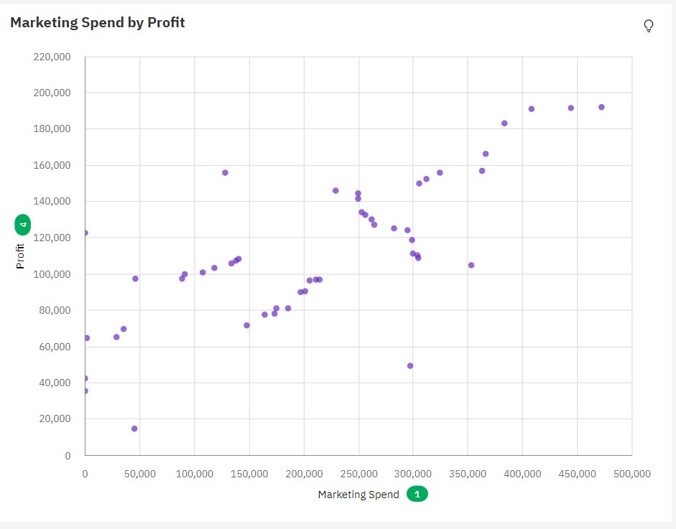

**Details:**

* The total number of results for Profit, across all marketing spends, is 108.
* The total of Profit is over 5.6 million.
* The average of Profit is nearly 52 thousand.
* Profit is unusually low when Marketing Spend is 297,114.
* Profit and Marketing Spend have a medium positive linear association, being Profit = 60299 + 0.2476 * Marketing Spend

**Profit by Marketing Spend (Line Chart):**

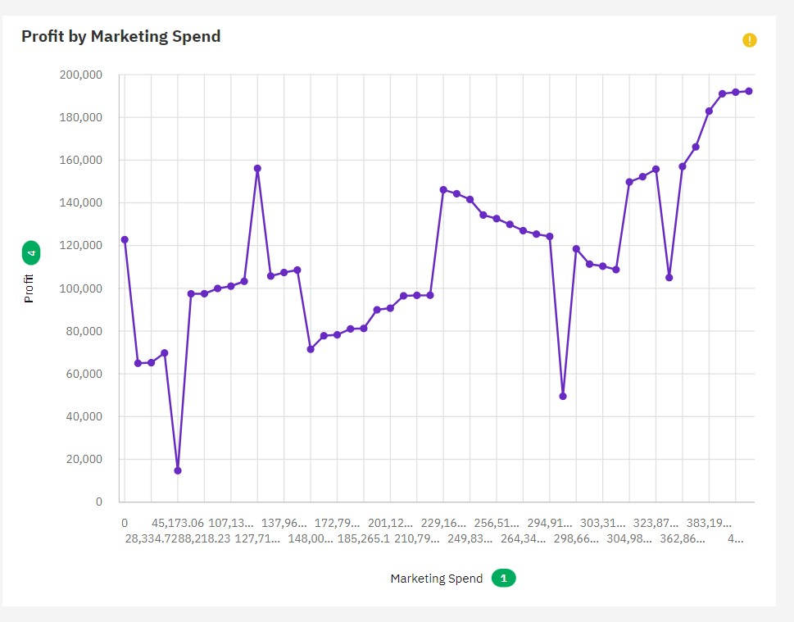

**Details:**

* The total number of results for Profit, across all marketing spends, is 108.
* Across all marketing spends, the sum of Profit is over 5.6 million.
* Over all marketing spends, the average of Profit is almost 52 thousand.
* The most common value of Marketing Spend is 0, occurring 6 times, which is 5.6 % of the total.
* The values of Profit range from nearly fifteen thousand, occurring when Marketing Spend is 45173.06, to over 192 thousand, when Marketing Spend is 471784.1.

**Total Profit state wise (Map):**

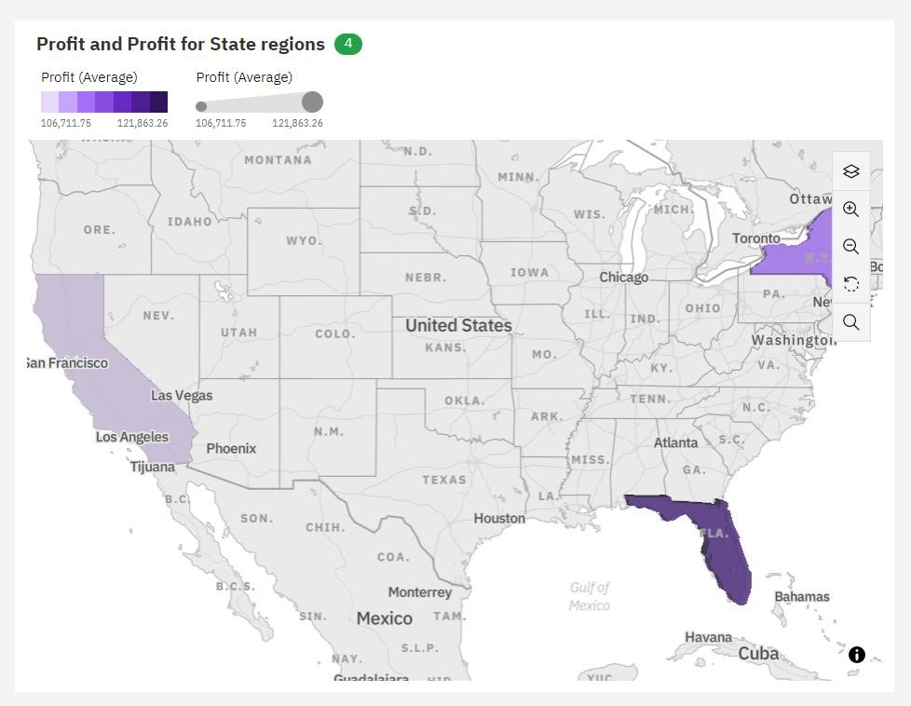

**Details:**

* The most common values of State are New York (36.1 %) and California (33.3 %), together occurring 75 times, which is 69.4 % of the total.
* The total number of results for Profit, across all states, is 108.
* Over all states, the average of Profit is nearly 114 thousand.
* The average values of Profit range from almost 107 thousand, occurring in California, to nearly 122 thousand, in Florida.